The New Jersey State Legislature

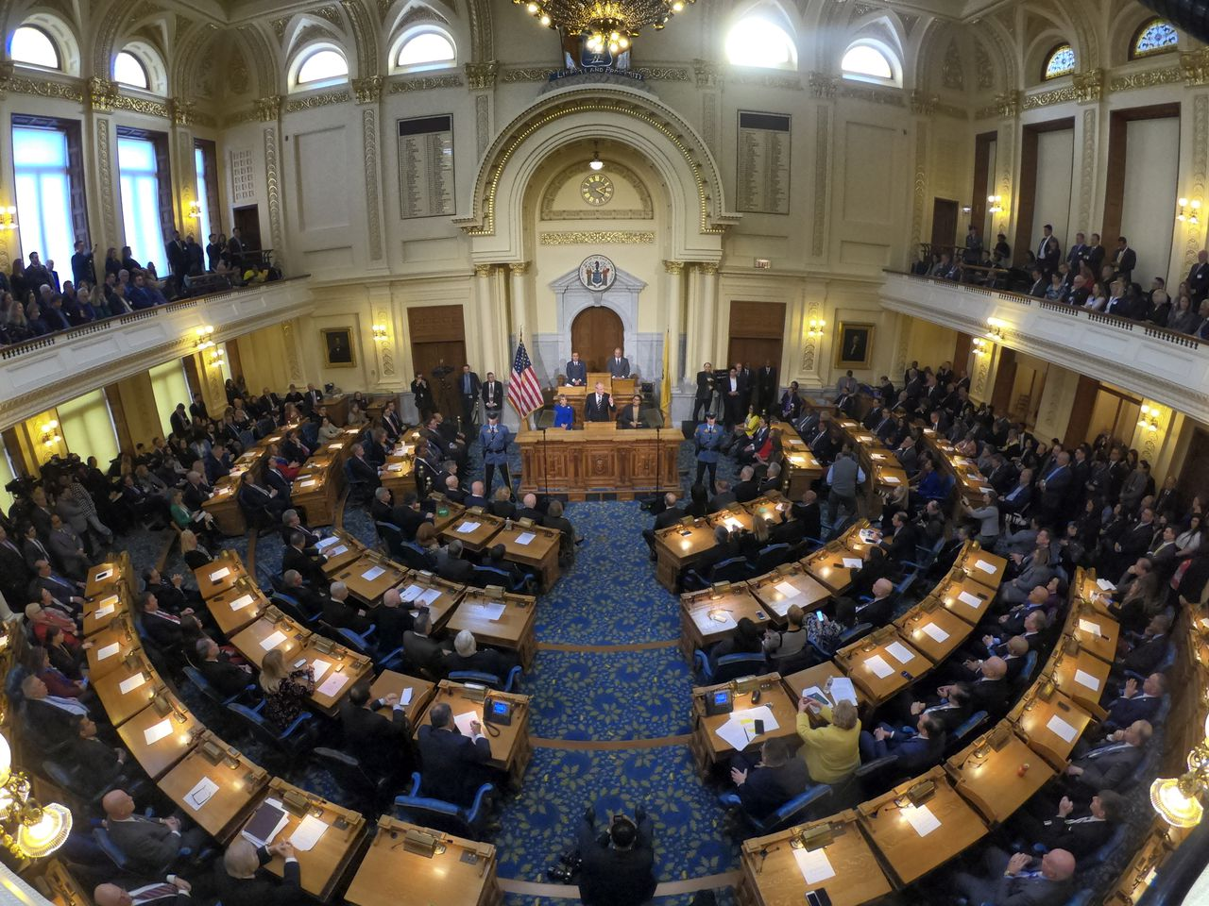

Members of the New Jersey state Legislature listen to Gov. Phil Murphy speak at the Statehouse in Trenton | NJ Advance Media

Prepared by: New Jersey Center for Civic Education, Rutgers University, Piscataway, NJ

Grade Level: 6-8 and 9-12

Objectives: Students will be able to:
- Describe the role of the Legislature
- Identify the requirements being a member of the New Jersey State Legislature
- Explain how a bill becomes a law in New Jersey
- Identify a public policy issue
- Participate in a legislative hearing on an issue affecting and upcoming election, law use, environment, health or other issue
- Collaborate on the development of a proposal to address a problem facing New Jersey
- Present a public policy proposal to the appropriate governmental officials.

New Jersey Student Learning Standards for Social Studies (2020):

6.3.8.CivicsPD.1: Deliberate on a public issue affecting an upcoming election, consider opposing arguments, and develop a reasoned conclusion.
6.3.8.CivicsPD.2: Propose and defend a position regarding a public policy issue at the appropriate local, state, or national level

6.3.8.CivicsPD.3: Construct a claim as to why it is important for democracy that individuals are informed by facts, aware of diverse viewpoints, and willing to take action on public issues.
6.3.8.CivicsPR.5: Engage in simulated democratic processes (e.g., legislative hearings, judicial proceedings, elections) to understand how conflicting points of view are addressed in a democratic society.
6.3.8.CivicsPR.7: Compare how ideas become laws at the local, state, and national level.
6.3.8.EconET.1: Using quantitative data, evaluate the opportunity cost of a proposed economic action, and take a position and support it (e.g., healthcare, education, transportation).

6.1.12.CivicsPI.13.a: Craft an argument as to the effectiveness of the New Jersey Constitution of
1947, New Jersey Supreme Court decisions (i.e., Hedgepeth and Williams v. Trenton Board of Education), and New Jersey’s laws in eliminating segregation and discrimination.
6.1.12.CivicsPI.14.a: Draw from multiple perspectives to evaluate the effectiveness and fairness of the processes by which local, state, and national officials are elected.
6.1.12.EconET.14.a: Use current events to judge what extent the government should intervene
at the local, state, and national levels on issues related to the economy.
6.3.12.CivicsPD.1: Develop plan for public accountability and transparency in government related to a particular issue(s) and share the plan with appropriate government officials.
6.3.12.EconGE.1: Participate in a simulated meeting (e.g., President's Council, World Bank, International Monetary Fund (IMF), research evidence from multiple sources about an economic problem (e.g., inflation, unemployment, deficit), and develop a plan of action.

Who can be a member of the New Jersey Legislature?

The New Jersey Legislature consists of two Houses: a 40-member Senate and an 80-member General Assembly. The Senate and Assembly chambers are located in the State House in Trenton. While legislators spend a considerable amount of their time on legislative matters, service in the Legislature is considered to be part-time, and most legislators also hold other employment. For more detailed information about the New Jersey State Legislature, go to http://www.njleg.state.nj.us/Default.asp

Activity 1: Have students look at the New Jersey State Constitution at https://www.njleg.state.nj.us/lawsconstitution/constitution.asp
and determine who can be a member of the New Jersey State Legislature.

- Senators must be at least 30 years old and residents of the state for four years prior to election.
- Members of the Assembly must be at least 21 and state residents for two years.
- All legislators must live in the districts they represent.

Who are your state legislators?

State Legislators are elected from 40 legislative districts of substantially equal population. The voters in each district elect one State Senator and two members of the State General Assembly. Every ten years, after the Federal census, the boundaries of the 40 districts are redrawn to maintain an equal population in each district. This reapportionment of districts is performed by a bipartisan Apportionment Commission, whose members are appointed by the state chairs of the two major political parties.

Legislative elections are held in November of each odd-numbered year. Members of the Assembly serve two-year terms. Senators serve four-year terms, except for the first term of a new decade, which is only two years. This "2-4-4" cycle allows for elections from new districts as soon as possible after each reapportionment. Interim appointments are made to fill vacant legislative seats by the county committee or committees of the party of the vacating person. The office is on the ballot for the next general election, unless the vacancy occurred within 51 days of the election. Then the appointment stands until the following general election.

Activity 2: Determine who your State Legislators are by going to http://www.njleg.state.nj.us/districts/districtnumbers.asp

How does a bill become a law?

The New Jersey Constitution provides that each Legislature is constituted for a term of two years, split into two annual sessions. The two-year legislative term begins at noon on the second Tuesday in January of each even-numbered year. At the end of the second year, all unfinished business expires.
Each House sets its own meeting schedule. A typical session day consists of party conferences around midday followed by open debate and voting activity in the chambers. Occasionally, committee meetings may be held on days when legislative voting sessions occur, but typically committee meetings are held on another day. While both voting sessions and committee meetings are typically on Mondays and Thursdays, committee meetings and public hearings can be held on any day, at the discretion of the committee chair.
Committee meetings and voting sessions are open to the public. No advance arrangements are necessary to gain admission to the meeting rooms or the public galleries of the chambers. Access for joint sessions, however is limited. Joint sessions occur when the Senate and General Assembly meet together, most often for an address by the Governor.

The role of the State Legislature is to pass bills, which are proposals to establish a new law or to change or repeal an existing law, which must be signed by the Governor. In addition, the State Legislature may pass concurrent resolutions by both the Senate and General Assembly to express the policy or opinions of the Legislature; often used to petition Congress to take certain actions; to establish study commissions composed entirely of legislators or appointees of the presiding officer, to adopt joint rules; and to propose amendments to the State Constitution. A concurrent resolution requires no action by the Governor. A joint resolution is a formal action adopted by both Houses and approved by the Governor. A joint resolution has the effect of a law and is often used instead of a bill when the purpose is of a temporary nature, or to establish a commission or express an opinion.

Activity 3: Have students research how a bill becomes a law. They might turn the steps into a rap song.

Here are the steps:
- Any Senator or General Assembly member may propose or sponsor a new law. Ideas for laws can come from many sources such as citizens, interest groups, public officials or the Governor.
- At the legislator's direction, the idea is drafted as a bill. The legislator may ask other legislators to become co-sponsors.
- The bill is introduced when the Senate Secretary or General Assembly Clerk reads aloud the bill's number, sponsor and title during a legislative session.
- The bill is usually sent to a committee which studies it and makes changes, if needed. These changes are called amendments. Committees have open meetings where the public may speak about the bill.
- If the committee approves the bill, it is reported to the House and its title is read again. This is the bill's second reading.
- When scheduled by the Senate President or Assembly Speaker, the bill's title is read for the third time, and it is debated and voted on. A bill passes if it receives a majority of votes (at least 21 in the Senate or 41 in the General Assembly).
- The bill follows a similar path of first reading, committee consideration, second reading, third reading and final passage in the second house. After both houses agree on the bill, it is sent to the Governor. In most cases, the bill becomes law when signed by the Governor.
- The Governor may veto a bill by refusing to sign it and returning it to the Legislature with noted objections or proposed changes. There are several types of vetoes. Sometimes, a vetoed bill can still become law.

Activity 4: Have students identify and research a problem that might be address by the state, then develop a proposal and send it to your state legislators.

- Have your students identify several potential problems to address. They could brainstorm from scratch with each student identifying a problem or the students could select from a list provided by the teacher.
- Students discuss and prioritize the community problems that have been identified by their scope (How many people are affected?), intensity (How important is this issue? Student might look at existing data or reports or do their own survey), and duration (is this a new problem or one that has been around for a while?)
- Students select one or several problems for the class or groups of students to research, gathering and evaluating information on the problem
- Student work in small groups to examine and evaluate the pros and cons of various alternative solutions
- Then students identify the public policy that they think, based on their research and evaluation, will best address the problem
- Finally, the students develop an action plan to get their policy adopted by the appropriate governmental agency (which may be the State Legislature, the Governor, an executive agency, a local town council, municipal or county agency, or local school board) and prepare (and send!) persuasive letters explaining their plan to the appropriate individual
- Have your students, individually and as a class, reflect on what they learned by using their research, critical thinking and communication skills to influence public policy to improve their community

You might want to consider using the framework provided by Project Citizen, project based civic education program for students grades 3-12 that emphasizes responsible participation in local and state government. The materials have been developed by the Center for Civic Education and are inexpensive in print or ebook format at store.civiced.org

Legislative Hearings:

Background: Legislative hearings are held by committees of the United States Congress, State Legislatures, and other legislative bodies to gather information on matters of public concern. These hearings are a basic function of legislative branches of government. Role-playing a legislative hearing provides participants with an opportunity to gain increased understandings of the purpose and procedures of such hearings as well as the roles and responsibilities of committee members. Participants also gain experience in identifying and clarifying the information, interests, and values associated with the subject being discussed.

Activity 5: Set up and conduct a mock legislative hearing.

- Clarify topics. Help students understand the topic of the legislative hearing. The topics are clearly identified in the lessons in the student text and in this edition. You also will want to ensure that student’s understand the role of committees in the legislative process.
- Contact resource person. Invite a local legislator, representative of local groups or chapters of a national organization to serve as resource people on the topic of the hearing.
- Assign Roles. Explain to participants the purpose of a legislative hearing and assign the appropriate roles:
  - Legislators. Six legislators in a practical number for a committee, but the number may vary according to class needs. Designate one legislator as the chairperson to preside over the hearing.
  - Witnesses. The number and nature of the witnesses depend o the topic being discussed. The specific roles described in the lessons and in this edition are designed to present differing points of view on the topic.
  - Recorder. This role is optional. This person will keep a record of the proceedings and present a review or summary of any recommendations that may emerge during the discussions.
  - Newspaper reporters. This role is optional. But is useful in helping students gain insights on the function of the press in the democratic process. Select student’s to represent newspaper with varying perspectives. Ask them to interview legislators and witnesses, to observe the proceedings, and to write brief articles or editorials about the topic. They should share and discuss their work with the class.
- Prepare presentations. Allow time for participants to prepare for the legislative hearing in accordance with their assigned roles.
  - Legislators should identify the key issue(s) and prepare questions to ask each witness.
  - Witnesses should define their position on the issue(s), prepare and opening statement, anticipate question from the legislators, and formulate possible responses
  - Witnesses may wish to discuss similarities in positions with other witnesses.
  - When appropriate, have a resource person work with the student or allow students to contact outside resources for assistance in preparing their position on an issue.
- Arrange the classroom. Set up the classroom to resemble a legislative chamber. Include a table for the legislators, a desk for the recorder, and a desk or table for the witnesses. Provide a gavel and name plates with the students’ names and their roles. You may want to arrange the use of a hearing or committee room of a local legislative body.
- Conduct the hearing. The following procedures should be used to conduct this activity:
  - The committee chairpersons call the hearing to order; announces the purpose of the hearing and the order in which the witnesses will be called to testify.
  - The chairperson calls each witness. The witness makes an opening statement. Followed by questions from members of the committee. You may want to establish time limits, usually three to four minutes for openings and five to six minutes for question from the legislators. Appoint a timekeeper to enforce time limitations.
  - The chairperson is the first to question the witness, followed by the other members of the committee. A committee member may interrupt to ask a question or make a comment any time during the proceedings.
  - After the witnesses have been heard, the legislators review the testimony. Discuss the issue(s) and make recommendations on what their next step(s) will be.

- Debrief the activity. Debriefing questions vary according to the topic. Begin by having the legislators announce their decision. Discuss the facts and arguments presented on the topic and evaluate the strengths and weaknesses of the positions taken. Ask students to evaluate their experience with the hearing process itself. Conclude the debriefing by having students discuss the effectiveness of this activity as a tool for learning, including how well they performed their role in it. If a resource person assisted with the activity, that person should be included in the concluding discussion.

Legislative Debates:

Legislative debate is often used productively in the formulation and development of laws. Role-playing a legislative debate provides participants with an opportunity to increase their understanding of the purpose and value of the power of legislatures to make laws and to debate matters of public policy.

Activity 6: Set up and conduct a mock legislative debate

- Clarify topics. Help students understand the topic of the legislative debate. The topics are clearly identified in the lessons in the student text and in this edition. You also will want to ensure that student’s understand the process whereby bills are enacted into law.
- Contact resource persons. Contact state and national legislators or their staff assistants to help serve as resource persons.
- Assign roles. Consider the entire class as the legislative body with a student or the teacher assuming the role of the presiding officer Legislators may then be assigned to groups representing various positons on the issue. Groups are clearly identified in the student text and in this edition. You also may want to assign a recorder responsible for tracking key points of discussion during the debate.
- Prepare presentations. Allow time for participants to prepare for the legislative hearing in accordance with their assigned roles.
  - Each group should select a spokesperson and a recorder and then proceed to follow the directions given in the lesson. Subtends should analyze and evaluate the issue before developing their positions. In some cases, they will be asked to offer amendments to the bills already given in the lesson. In others, they may write a proposed bill designed to alleviate problems raised by the issue.
  - As each group completes its amendment or proposed bill, the spokesperson reports to the presiding officer asking that the bill be placed on the agenda. Bills should be placed on the agenda in the order in which they are received. Students may wish to discuss any similarities in their proposed amendments or bills with other groups to predetermine whether they can unite behind a common proposal.
- Arrange the classroom. Set up the classroom to resemble a legislative chamber. Include a table for the legislators, a desk for the recorder, and a desk or table for the witnesses. Provide a gavel and name plates with the students’ names and their roles. You may want to arrange the use of a hearing or committee room of a local legislative body.
- Conduct the legislative debate. Time limits for the various steps in legislative debates should be decided ahead of time. The presiding officer should be empowered to cut off speakers when the time limit has been reached. Conduct the legislative debate using the following procedures:
  - The presiding officer calls the legislature to order, indicates that all voters will be decided by a simple majority, announces the issue, and opens the debate.
  - The first bill on the agenda is introduced by the group’s spokesperson. The spokesperson stands, addresses the presiding officer, and describes the bill the group has written. After presenting the bill, the spokesperson may recognize two other members of the group who may make additional comments on the bill.
  - The bill is discussed and debated by the legislature. Representatives from other groups may ask questions, offer criticisms, or suggest modifications.
  - The steps above are repeated for any additional bills that might be introduced during the session.
  - When the discussion and debate on all proposed bills is completed, legislators may move that one of the bills be voted on or that the session is recessed to enable the groups to consider the bills that have been presented. If the session is recessed, each group meets to decide upon a course of action. A group may decide to support one of the bills as presented, suggest amendments to one of the bills presented, or develop a compromise bill.
  - When the session is reconvened, the presiding officer asks for a motion to vote on one of the bills as presented, for a motion to amend of the bills, or for the introduction of a compromise bill. If amendments or comprise bills are proposed, they are individually debated and voted upon.
  - This process is repeated until a bill is passed or the time allotted for the sessions is up and the legislature is adjourned.
- Debrief the activity. Debriefing questions vary according to the topic. Discuss the facts and arguments presented on the topic and evaluate the strengths and weakness of the positions taken. Also ask students to evaluate their experience with the legislative process itself. Conclude the debriefing by having students discus the effectiveness of the activity as a tool for learning, including how well they performed their role in it. If a resource person assisted with the activity, that person should be included in the concluding discussion.

Extension

The Office of Legislative Services Tour Office offers FREE programs and tours at the State House. Trained staff and volunteers provide tours and programs that match school curriculum and bring the lessons of the classroom to life in our State's capitol! Go to www.njstatehousetours.org

The Eagleton Institute of Politics at Rutgers University administers a grant program targeted at helping Middle and High School students visit the State House. The grant is funded by the New Jersey State Legislature and provides schools with funds to help pay for the cost of transportation. More information can be found at: https://cypp.rutgers.edu/for-educators/state-house-express/.

