Judicial Appointments
Background on the process for judicial appointments to the U.S. Supreme Court
Article III Section I of the United States Constitution establishes and empowers the judicial branch of the national government: “The judicial Power of the United States, shall be vested in one supreme Court, and in such inferior Courts as the Congress may from time to time ordain and establish.” The Constitution merely established one Supreme Court, which was to be separate from both the legislative branch (Congress) and the executive branch (the President). It left to Congress to decide what other federal courts we would establish.
Article II, Section II of the United States Constitution provides that the president "shall nominate, and by and with the Advice and Consent of the Senate, shall appoint Ambassadors, other public Ministers and Consuls, Judges of the Supreme Court, and all other Officers of the United States, whose Appointments are not herein otherwise provided…” This clause is one example of the system of checks and balances embedded in the Constitution. The President has the power to nominate, while the Senate possesses the power to reject or confirm the nominee. Today, we have a three-level federal court system—trial courts, courts of appeals, and the Supreme Court—with about 800 federal judges. The president nominates all federal court judges, including Supreme Court justices, court of appeals judges, and district court judges. The Senate Judiciary Committee typically conducts confirmation hearings for each nominee. Nearly a quarter of all Supreme Court nominations have failed to be confirmed by the Senate, their nominations rejected, withdrawn, or not acted upon.
The nominee must answer an elaborate questionnaire, including sources of income, interviews with the news media, writings and a list of former clients. The F.B.I. will conduct a background check, and the Judiciary Committee will start its own background investigation. The nominee will meet with as many senators as possible. The senators are usually looking to learn about how the nominee thinks, while the nominee is trying to learn the concerns that the senators may have. Formal, televised hearings will be conducted by the 22 members of the Senate Judiciary Committee (12 from the majority party and 10 from the minority party). The hearings have typically lasted for three or four days, but they can be shortened. After the hearings, the committee will vote to send the nomination to the full Senate.
Senate cloture rules historically required a two-thirds affirmative vote to advance nominations to a vote; this was changed to a three-fifths supermajority in 1975. In November 2013, the then-Democratic Senate majority eliminated the filibuster for executive branch nominees and judicial nominees except for Supreme Court nominees, invoking the so-called “nuclear option”. In April 2017, the Republican Senate majority applied the nuclear option to Supreme Court nominations as well, enabling President Trump’s nomination of Neil Gorsuch to proceed to a vote with a mere majority.
Nominations in an election year
Judicial nominations are supposed to have bipartisan support. They are often controversial. Since 1968, the Senate has followed an unwritten rule or practice that sometime after spring in a presidential election year, no judges will be confirmed without the consent of the Republican and Democratic leaders and the judiciary chairman and ranking minority member. However, when U.S. Supreme Court Justice Antonin Scalia died on February 16, 2016, 269 days before the presidential election, Senate Majority Leader Mitch McConnell insisted that the U.S. Senate would not consider any Supreme Court nominee put forth by President Obama, stating that "The American people should have a voice in the selection of their next Supreme Court justice. Therefore, this vacancy should not be filled until we have a new president”. A month later on March 16, 2016, President Obama nominated Judge Garland, who had served for 19 years on the United States Court of Appeals for the District of Columbia Circuit, three as its chief, and was a well-known moderate, to fill the position. Under Senator McConnell's direction, Senate Republicans refused to take any action on the Garland nomination, which expired on January 3, 2017, with the end of the congressional session. The Supreme Court seat left vacant by the death of Justice Antonin Scalia was unfilled for more than 400 days, the longest opening on the court since the 1860s.
On rare occasions (specifically in 1828, 1844, 1852, 1860, 1968), the president has nominated someone for the U.S. Supreme Court within a year of a presidential election and that nominee has not been confirmed by the Senate (See the attached chart). However, there is no instance where the Senate has refused to even consider a judicial nominee as was done in 2016 with Judge Garland. Senator McConnell's refusal to hold Senate hearings on Supreme Court nominee Merrick Garland during Obama's final year in office was described by many political scientists and legal scholars as "unprecedented", a "blatant abuse of constitutional norms".
On September 18, 2020, Justice Ruth Bader Ginsburg died. This left an opening on the U.S. Supreme Court 46 days before the November 3, 2020 election. Senate Majority Leader Mitch McConnell argued that President Trump should nominate and the Senate should consider the nomination as soon as possible rather than waiting for the public to speak in the upcoming November elections, even though a third of the Senate seats were up for election as well as the presidency. He explained his change of position in 2020 based on the fact that the Republicans have the presidency and the Senate, whereas there was a Republican controlled Senate in 2016. A week later, on September 26, 2020, President Trump announced his nomination of Judge Amy Coney Barrett, who has been a judge on the U.S. Court of Appeals for the Seventh Circuit for three years and is known for her conservative opinions, especially opposing abortion and the Affordable Care Act (“Obamacare”), to fill the position on the Supreme Court.
Of the 16 vacancies on the Supreme Court that occurred in the year before a presidential election, only one has been closer to Election Day than the situation in 2020 (See the attached chart). On October 12, 1864, U.S. Supreme Court Chief Justice Roger Taney died, 27 days before the November 1864 election. In spite of the fact that it was the height of the Civil War, President Lincoln had enormous emergency powers, and the Republican Party firmly controlled the Senate (since the Democratic Southern states had all seceded), President Lincoln waited until after the election to seek confirmation of his nominee, Salmon Chase, who had been his Treasury Secretary, to fill the Supreme Court position. We do not know exactly what President Lincoln was thinking at the time (there is no existing public explanation), but his actions spoke louder than words.
The other Supreme Court nomination closest to an election was that of William Brennan in 1956, but the facts are quite different. On Sept. 7, 1956, Justice Minton, in failing health, sent a letter to President Eisenhower indicating that he would like to retire as soon as he could be replaced. On October 16, 1956, President Dwight D. Eisenhower gave New Jersey Supreme Court Justice William Brennan a recess appointment to the United States Supreme Court and Justice Minton retired. Three months later, on January 14, 1957, William Brennan was formally nominated to the Court, and the Senate confirmed the appointment on March 19, 1957.
Article II, Section 2 of the U.S. Constitution provides that: “The President shall have Power to fill up all Vacancies that may happen during the Recess of the Senate, by granting Commissions which shall expire at the End of their next Session”. Thus, when the Senate is in recess, the President may make a temporary appointment to any office requiring Senate approval, including filling vacancies on the Supreme Court, without the Senate's advice and consent. Such a recess appointee to the Supreme Court holds office only until the end of the next Senate session (less than two years). To continue to serve thereafter, the nominee must be formally nominated by the president and confirmed by the Senate.
No president since Dwight Eisenhower has made a recess appointment to the Supreme Court and the practice has become highly controversial. In 1960 the Senate passed a resolution stating that it was the sense of the Senate that recess appointments to the Supreme Court should not be made except under unusual circumstances. Being a resolution, it has no legally binding effect, but was intended as an expression of the position of the Senate and as a guide to executive actions. The Democratic leadership of the Senate specifically blocked President George W. Bush from making any recess appointments with the use of pro forma sessions (where no formal business is expected to be conducted). Normally, the Senate is in recess during August and for several weeks in the fall (September-October) for campaigning.
In 2012 President Obama attempted to make four (non-judicial) appointments during a pro forma session, calling the practice of blocking recess appointments into question. However, in 2014 the U.S. Supreme Court held in NLRB v. Noel Canning that the President had improperly used his presidential power to make these recess appointments, stating that while the Senate was in recess punctuated by pro forma sessions the period of time between the sessions was not long enough to invoke such power. Thus, a recess appointment of Judge Garland by President Obama was not an option.
The fact remains, however, that the only vacancy closer to an election than the one in 2020 was not filled until after the election.
Adding new members to expand the U.S. Supreme Court
The number of justices on the United States Supreme Court has not always been nine. The initial U.S. Supreme Court included six justices. The Judiciary Act of 1789, by which Congress established the federal judiciary, declared that: “the Supreme Court of the United States shall consist of a chief justice and five associate justices”. In 1801, President John Adams and a lame-duck Federalist Congress passed the Judiciary Act of 1801, which reduced the Court to five Justices in an attempt to limit incoming President Thomas Jefferson’s appointments to the high bench. However, Jefferson and his Republicans soon repealed that act, putting the Court back to six Justices and in 1807, President Jefferson and Congress added a seventh member to the U.S. Supreme Court when they added a seventh federal court circuit.
In early 1837, President Andrew Jackson added two more Justices, bringing the total to nine, after Congress again expanded the number of federal circuit court districts. Under different circumstances, Congress created a 10th circuit in 1863 during the Civil War, and it briefly had a 10th Supreme Court Justice. However, after the war Congress passed the Judicial Circuits Act of 1866 to reduce the Court to seven Justices. That only lasted until 1869, when a new Judiciary Act set the number back to nine Justices, with six Justices required at a sitting to form a quorum.
On February 5, 1937, President Franklin Roosevelt announced a controversial plan to expand the Supreme Court to as many as 15 judges, allegedly to make it more efficient. The Judiciary Act of 1937 would have provided retirement at full pay for all members of the court over 70. If a justice refused to retire, an “assistant” with full voting rights was to be appointed, thus ensuring Roosevelt a liberal majority. Critics immediately charged that Roosevelt was trying to “pack” the court and thus neutralize Supreme Court justices hostile to his New Deal. Some Democrats as well Republicans opposed the idea. Before the bill came to a vote in Congress, two Supreme Court justices changed their views and by a narrow majority upheld as constitutional the National Labor Relations Act and the Social Security Act. Aside from President Franklin Roosevelt’s ill-fated threat to support an effort to add new Justices (who sympathized with his policies) to the Supreme Court, the number of Justices on the Court has remained stable at nine.
Changing the Constitution to include age or term limits for members of the U.S. Supreme Court
Under Article II, Section I of the U.S. Constitution “The Judges, both of the supreme and inferior Courts, shall hold their Offices during good Behaviour, and shall, at stated Times, receive for their Services, a Compensation, which shall not be diminished during their Continuance in Office.” Thus, federal court judges, including the justices of the U.S. Supreme Court, are appointed for a life term. The Founders wanted federal judges, including the justices of the United State Supreme Court, to serve for life so that they would be free from political influence and the court could serve as an independent branch of government. Alexander Hamilton explained in The Federalist No. 78 that judicial independence “is the best expedient which can be devised in any government to secure a steady, upright, and impartial administration of the laws.”
The language about “holding offices during good behaviour” has been interpreted to mean that the only way federal judges can be removed from office is if the House of Representatives impeaches them, and the Senate convicts them, of “treason, bribery, or other high crimes and misdemeanors.” Only fifteen judges have ever been impeached (that is, formally accused by the House of Representatives) and only eight have been convicted and removed from office. For practical purposes, any judge who does not commit a crime (or does something equally bad) has “lifetime tenure” and will stay in office until he or she dies or voluntarily steps down. And, as the provision says, Congress and the President cannot retaliate against judges by reducing their salaries.
Lifetime tenure for federal judges, however, has been criticized because it causes judges to stay in their positions longer than they should—after they have become too old to do their job well, either just because of age or because they are out of touch with modern times. For example, in 1858 Nathan Clifford, known for his pro-slavery views, was narrowly confirmed as justice on the U.S. Supreme Court. He served until 1881, by which time he was described as a “helpless lunatic”.
Most state court judges—unlike federal judges—are elected, not appointed; and some have to be re-elected, or approved by the voters, every few years. However, electing judges has often been criticized because judges might think they have to do politically popular things, or build political connections in order to keep their jobs, even if that means ruling in a way that does not follow the law. Few people argue that federal judges should be elected. Other states, like New Jersey, require state court judges, including the members of the State Supreme Court, to retire at age 70. Some critics suggest that federal judges, especially Supreme Court Justices, should be appointed for a fixed term of years—say 14 or 18 years—with no chance of being reappointed—or have a set retirement age. They still could not be fired and, since they would have to leave at the end of their term, they would have no reason to shape their rulings in a way that pleases powerful figures or popular opinion. So judicial independence would be maintained. It would provide for a more orderly transfer to a new justice since the retirement age would be known beforehand, rather than the current system where a seat on the court only becomes open when a current justice dies, making it difficult to plan for a replacement. But a change like this would require a constitutional amendment: A proposal supported by a 2/3 vote in both houses of Congress and ratified by 3/4 of State Legislatures (used 26 times) or supported by a 2/3 vote in both houses of Congress and ratified by conventions held in 3/4 of states (used once).
Critical Thinking Activities:
- Divide your class into several small groups.
  - Have group 1 consider and prepare an explanation about how the judicial nomination process works.
  - Have group 2 consider and prepare an explanation of why the process for nominating federal court judges is important in the nation’s balance/separation of powers?
  - Have group 3 consider and prepare an explanation of the issues at stake in the nomination of Judge Amy Coney Barrett.
  - Have group 4 explain why citizens should care about the process of nominating and confirming federal judges, especially justices of the U.S. Supreme Court. Have the four groups share their explanations and prepare a chart with all three topics.
- Have individual students write short essays:
  - Should the Senate vote on the nomination of Judge Amy Coney Barrett? Support your conclusion.
  - Should the Democrats if they win the presidential election and Senate majority, push for expanding the number of U.S. Supreme Court justice from 9 to 11? Support your conclusion.
  - Should we have a constitutional amendment to limit the terms of federal court judges, including justices of the U.S. Supreme Court, to age 70, or 18 years? Support your conclusion.
- Have a class discussion about the three topics. Identify the strongest arguments pro and con for:
  - confirmation hearings in a presidential election year,
  - expanding the number of justice on the U.S. Supreme Court, and
  - having term limits by number of years served or age for federal court judges, including Supreme Court justices.
Background on Judicial Appointments
U.S. Supreme Court Historical Society: https://supremecourthistory.org/htcw_selectingjustices.html
United States Courts: https://www.uscourts.gov/judges-judgeships/authorized-judgeships/judgeship-appointments-president
National Constitution Center: https://constitutioncenter.org/interactive-constitution/interpretation/article-iii/clauses/45
National Review (conservative news media): https://www.nationalreview.com/2020/08/history-is-on-the-side-of-republicans-filling-a-supreme-court-vacancy-in-2020/ and https://www.nationalreview.com/corner/supreme-court-why-no-justice-has-beenconfirmed-in-the-fall-of-a-presidential-election-year/
National Geographic: https://www.nationalgeographic.com/history/2020/09/how-supreme-court-vacancies-confirmed/#close
NPR Radio: https://www.npr.org/2020/09/21/915171218/should-the-next-supreme-court-justice-be-nominated-before-the-election
CNN: https://www.cnn.com/2020/09/21/politics/supreme-court-nomination-process-explainer/index.html
New York Times (https://www.nytimes.com/video/us/politics/100000007353515/republicans-supreme-court-hypocrisy.html?searchResultPosition=18
New York Times (Sept. 26, 2020): https://www.nytimes.com/2020/09/26/us/politics/amy-coney-barrett-supreme-court.html?searchResultPosition=3
New York Times (Sept. 22,2020): https://www.nytimes.com/2020/09/22/us/politics/trump-supreme-court.html?searchResultPosition=1
New York Times (Sept. 19, 2020): https://www.nytimes.com/2020/09/19/us/politics/rbg-vacancy-senators.html?searchResultPosition=50
New York Times (March 31, 2017): https://www.nytimes.com/2017/03/31/insider/the-good-old-days-of-supreme-court-nominations-they-dont-exist.html?searchResultPosition=3
New York Times (March 20, 2017): https://www.nytimes.com/interactive/2016/02/15/us/supreme-court-nominations-election-year-scalia.html?searchResultPosition=20
New York Times (Feb. 1, 2017): https://www.nytimes.com/2017/02/01/learning/lesson-plans/evaluating-trumps-nomination-of-judge-gorsuch-to-the-supreme-court-a-lesson-plan.html?searchResultPosition=2
New York Times (March 17, 2016): https://learning.blogs.nytimes.com/2016/03/17/news-qs-obama-chooses-merrick-garland-for-supreme-court/?searchResultPosition=6
HANDOUT: SUMMARY OF SUPREME COURT VACANCIES IN ELECTION YEARS
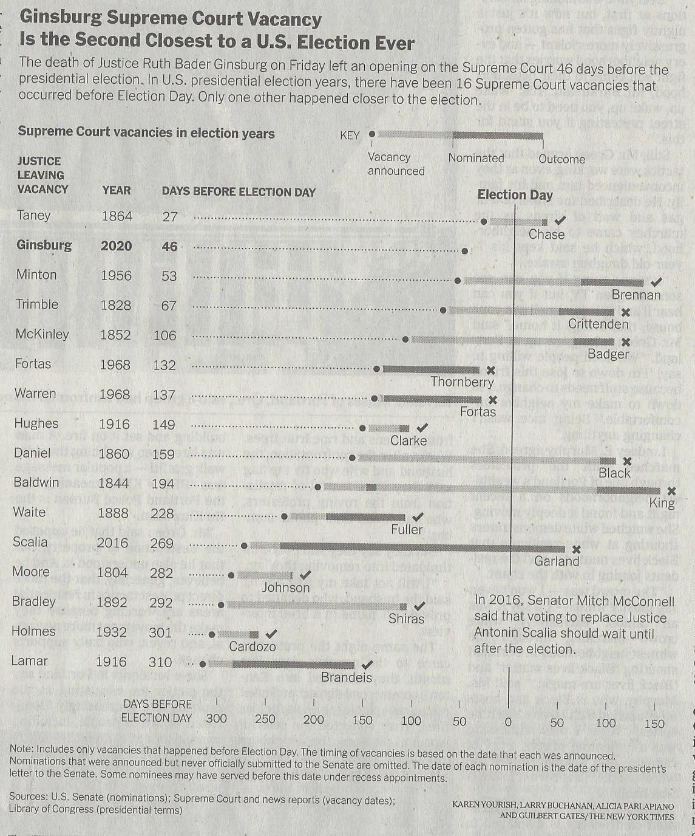
The New York Times, “Senators Line Up to Assist Trump in Quickly Filling Supreme Court Post,” p. A19 (Sept. 22, 2020)

